**Steps:**

1. **Create a Elastic Beanstalk**

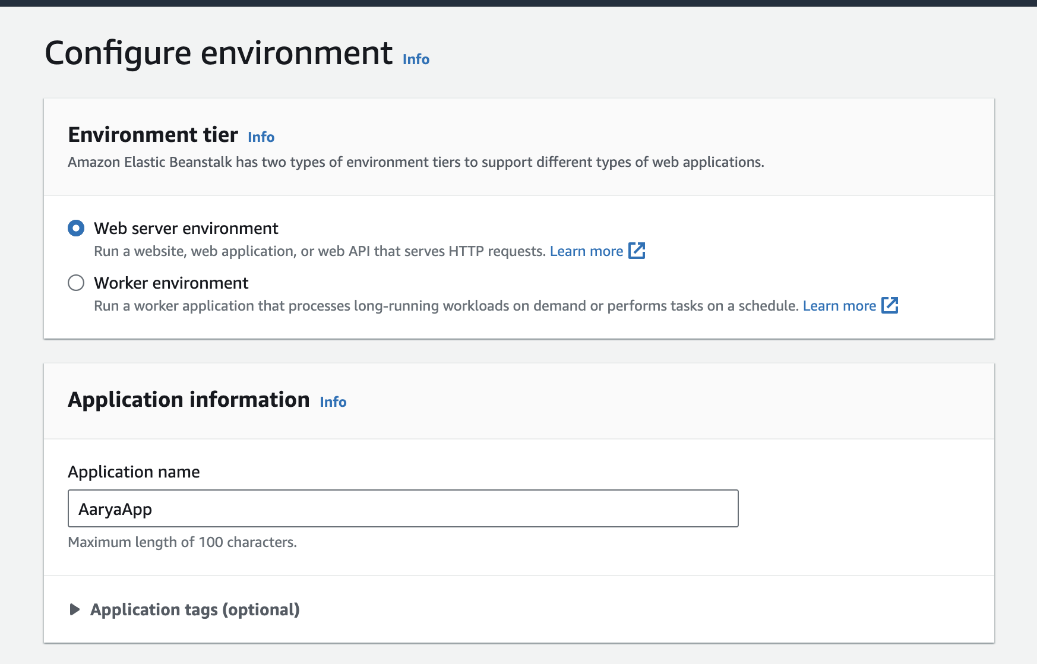

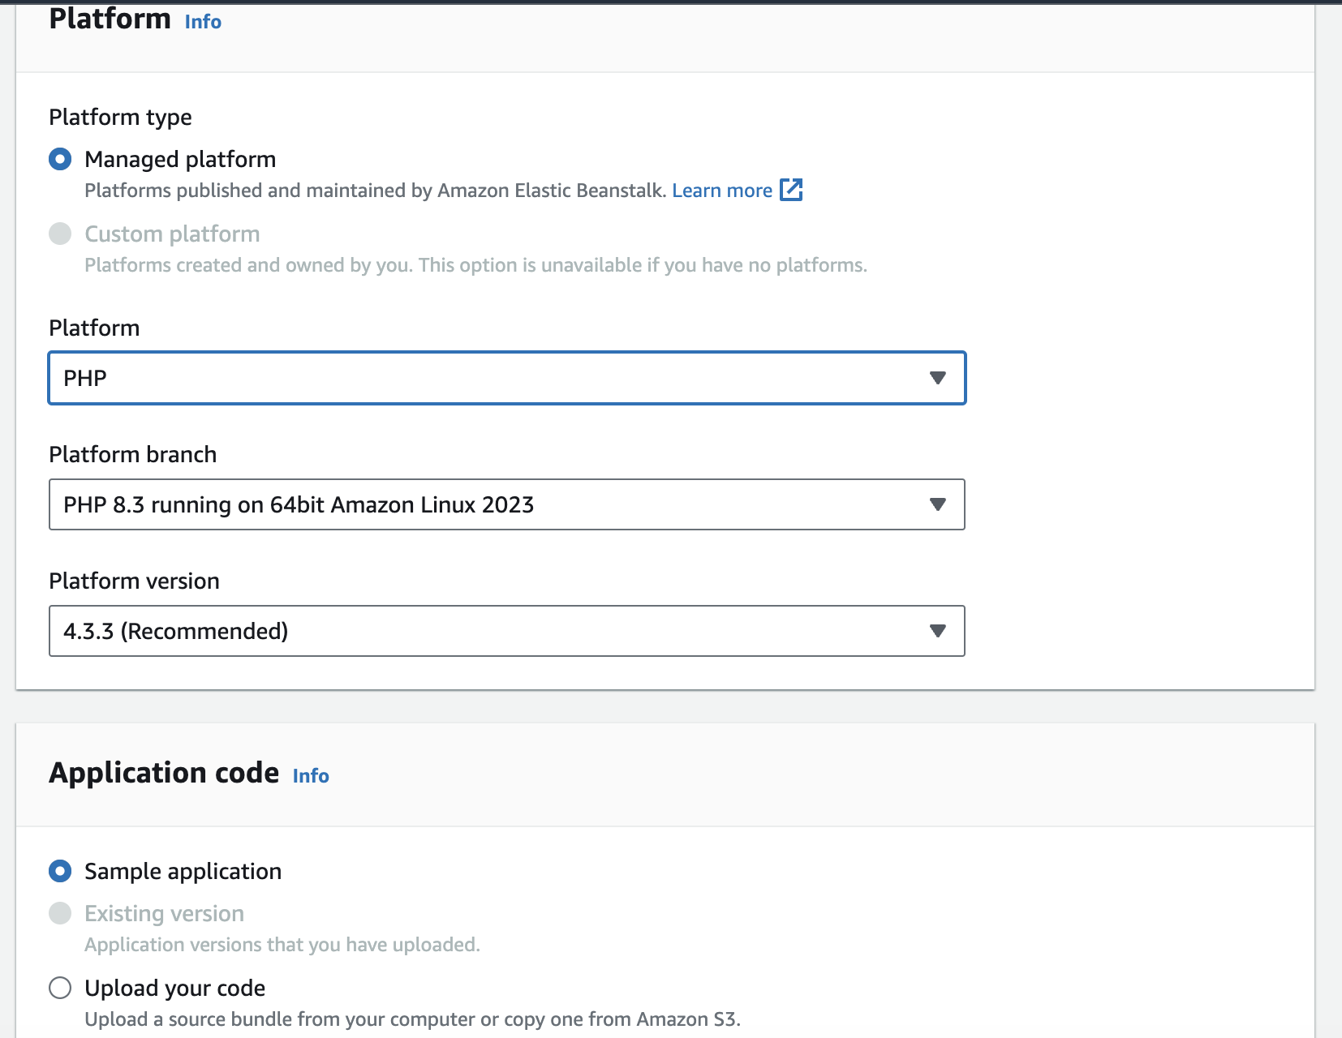

1. **Bucket Creation**

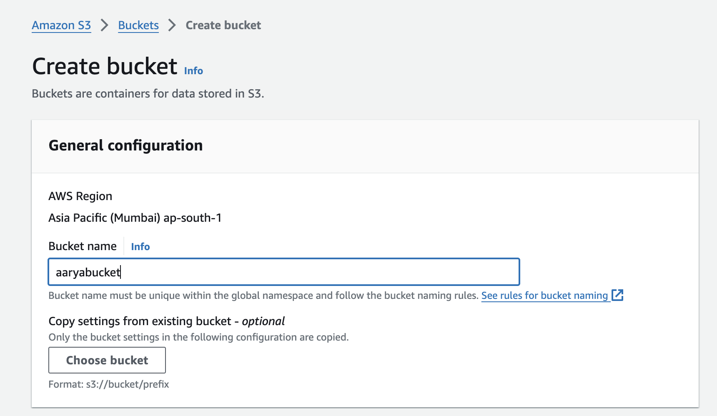

Then download the sample file,which needs to be deployed

Link: <https://github.com/imoisharma/aws-codepipeline-s3-codedeploy-linux-2.0>

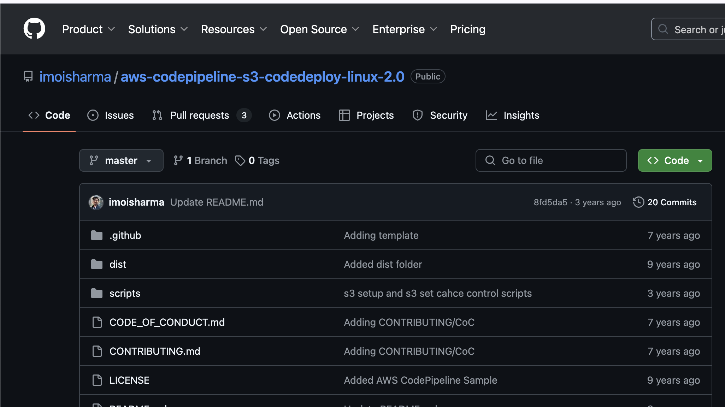

Upload the zip file onto the newly create bucket

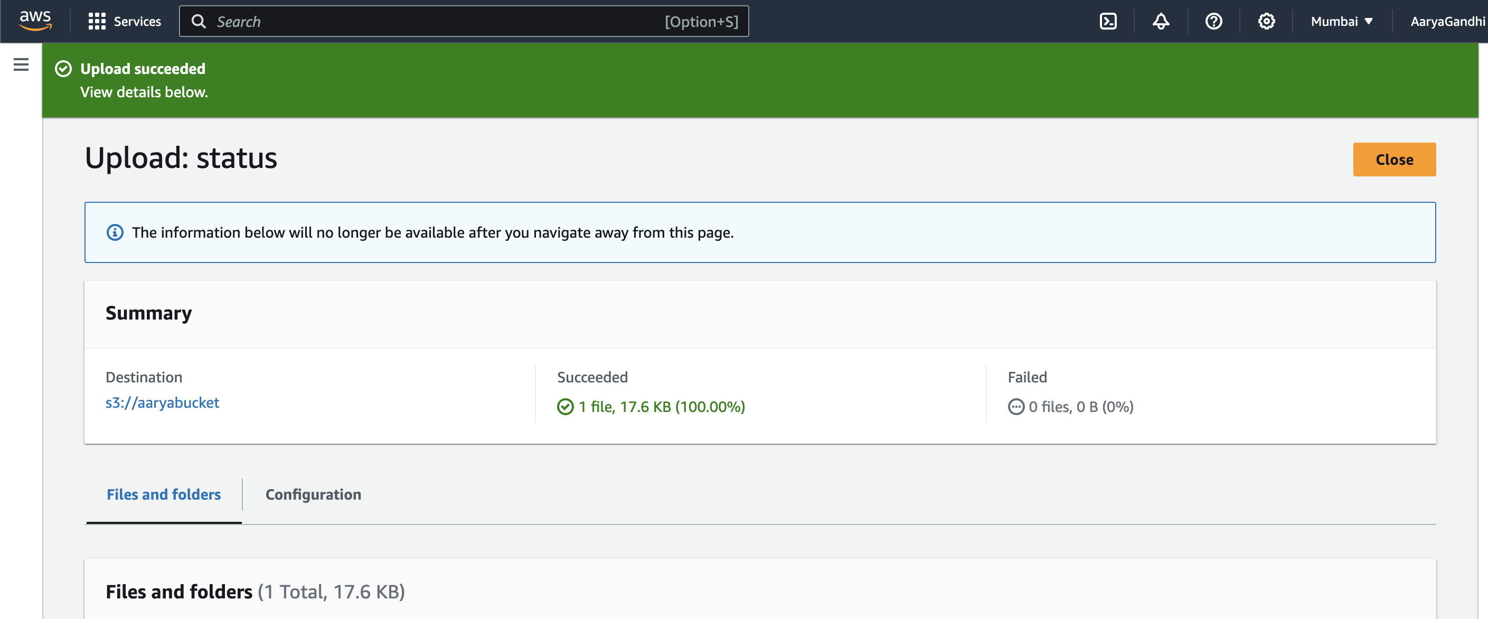

1. **Creating Pipeline** 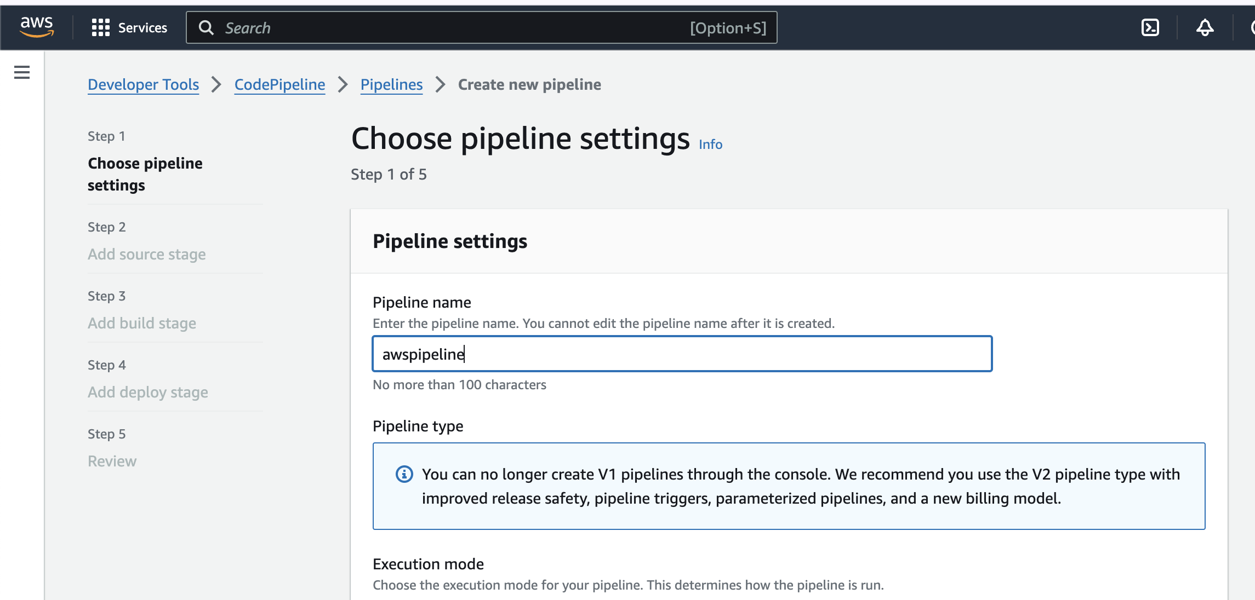

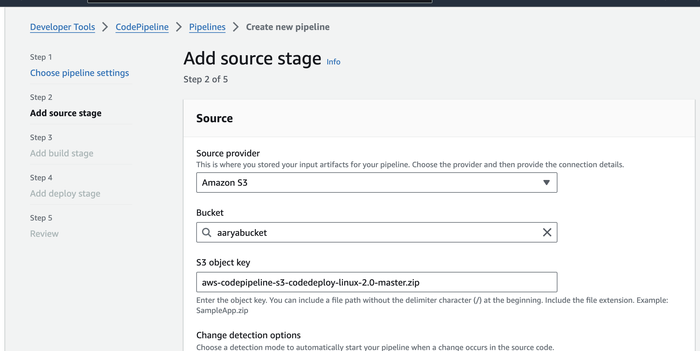

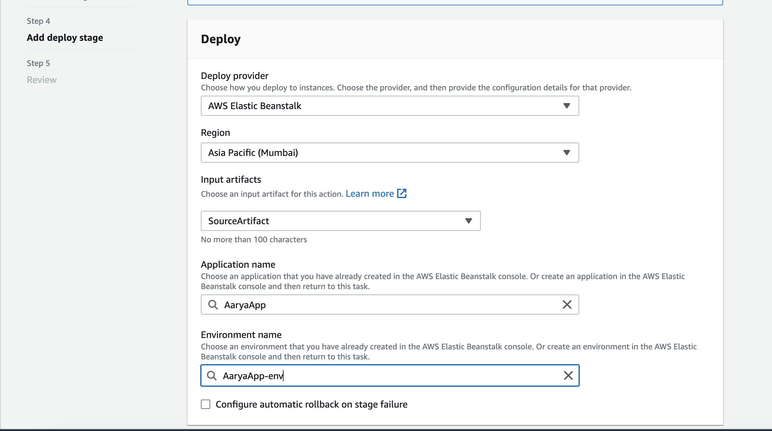

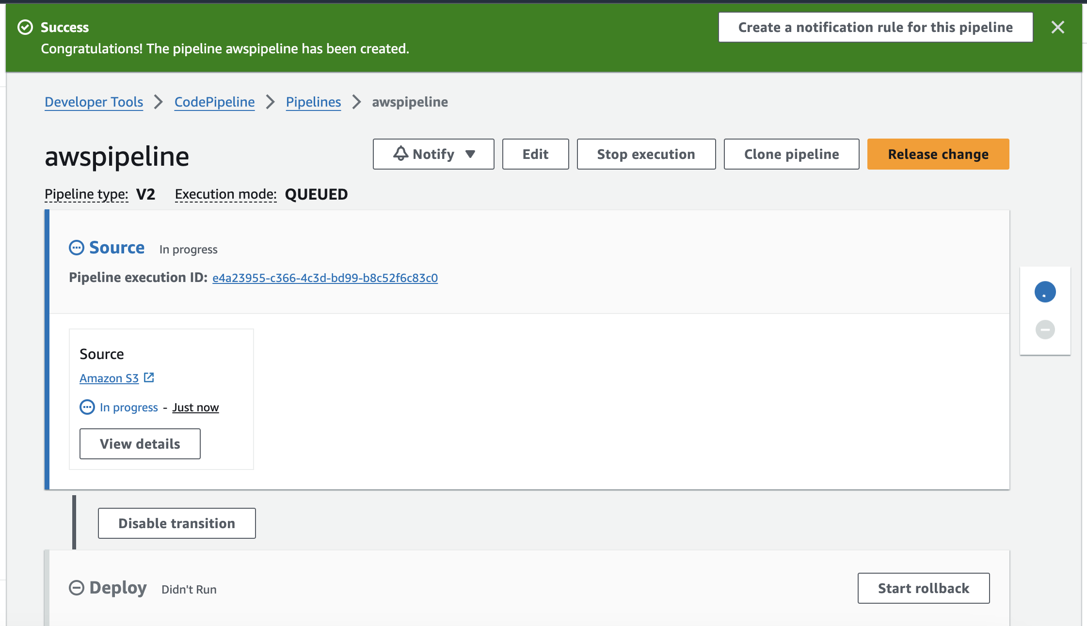

**Viewing the deplyed file:**

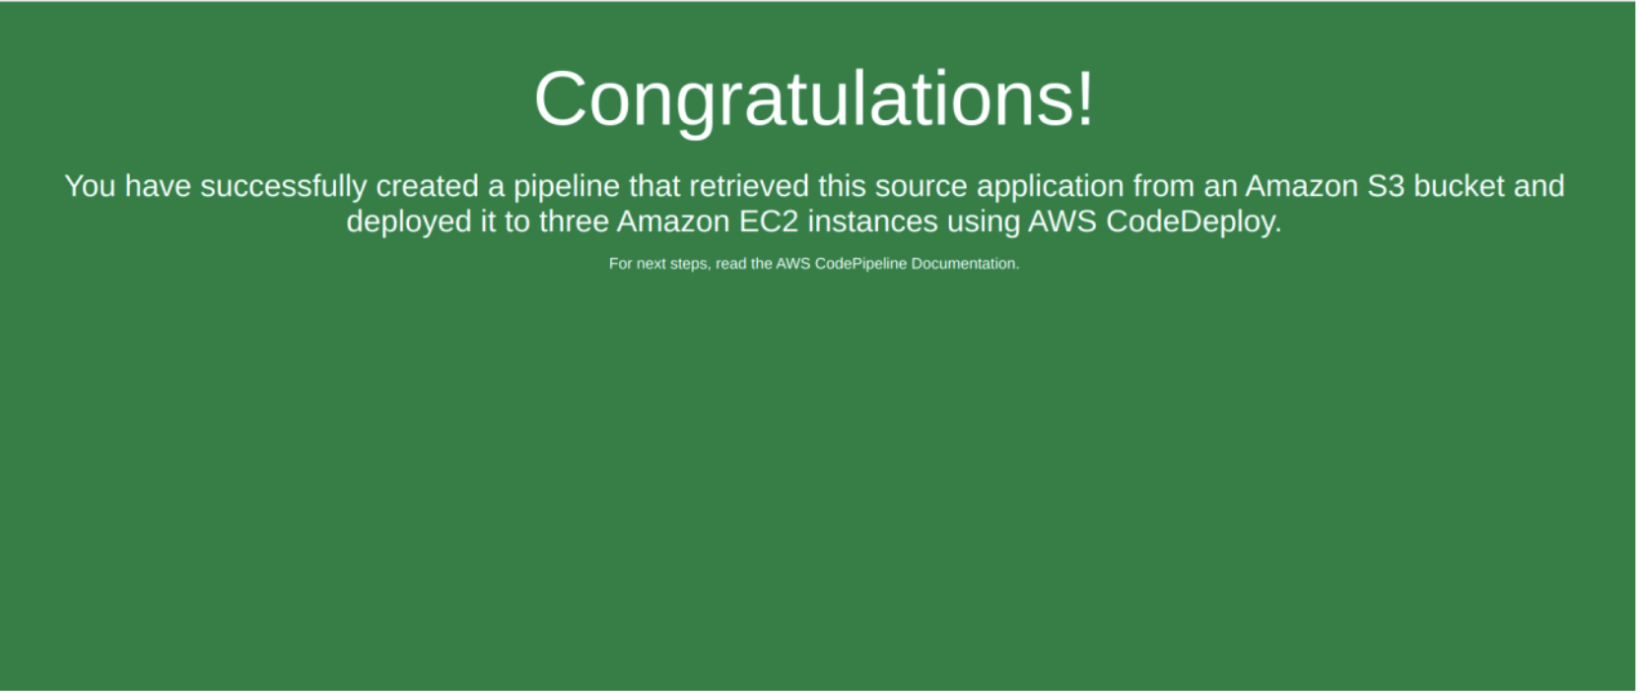

**After updation:**

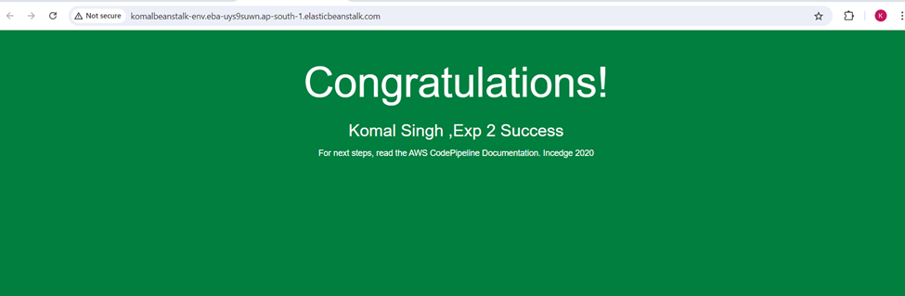

Aarya Gandhi

**Conclusion:**

Building and deploying an application using AWS CodeBuild, CodePipeline, and CodeDeploy demonstrates the power of automated CI/CD in the cloud. AWS CodeBuild compiles code, runs tests, and prepares software packages, while CodePipeline automates the release process, ensuring faster and consistent deployments. Deploying to S3 or SEBS enables scalable hosting of static and serverless applications, and CodeDeploy manages the deployment to EC2 instances, ensuring minimal downtime and easy rollback. This streamlined approach enhances development efficiency, reduces errors, and accelerates application delivery, showcasing the benefits of cloud-based automation and infrastructure management.